**Ride Management Application for Bajajs in**

**Gondar City**

**by**



**University of Gondar**

**Faculty of Informatics**

**Department of Information System**

**Group Members**

Name Id No

1. Assefa Demses 00737/12
2. Dereje Aragaw 02236/12
3. Fikir Getu 01627/12
4. Firaol Teklu 01156/12
5. Henok Gashew 01181/12

A Group Project

Submitted to the Department of Information Systems, Faculty of Informatics, University of Gondar, in meeting the preliminary project requirement for partial fulfillment of the award of Bachelor of Science Degree in Information Systems.

Gondar, Ethiopia

Date/Year: March 2023

**Approval Sheet**

This Group Project entitled “Ride Management Application for Bajajs in Gondar City” has been read and approved as meeting the preliminary project requirements of the Department of Information Systems in partial fulfillment for the award of a Bachelor of Science degree in Information Systems, University of Gondar, Gondar, Ethiopia.

**Approved by:**

1. Name of Advisor: ___________________________ Signature: ___________Date:________
2. Name of Project Coordinator: __________________ Signature: ___________Date:________

# **Acknowledgments**

First and foremost, We would like to thank God. Then We would like to express our deepest gratitude to Mrs. Tigist Ayeragn of the Transport Bureau of Gondar City and ZayRide’s Gondar Branch for providing the necessary information for the project. We would also like to give special thanks to our advisor Teshome Aychluhm for his tremendous support and guidance throughout the project.

Finally, we would like to thank everyone whose names were not mentioned but who helped us throughout the project.

Table of Contents

**CHAPTER ONE** 1

**1.** **Introduction** 1

**1.1.** **Background of the project** 1

**1.2.** **Statement of Problem** 1

**1.3.** **Project objectives** 1

**1.3.1.** **General Objective** 1

**1.3.2.** **Specific Objective** 1

**1.4.** **Scope of the project** 2

**1.5.** **Limitations of project** 2

**1.6.** **System Development Methodology** 2

**1.6.1.** **System development Approach** 2

**1.6.2.** **System Development Tools** 2

**1.7.** **Significance of Project** 2

**1.8.** **Beneficiaries of the project** 3

**1.9.** **Feasibility Study** 3

**1.10.** **Project schedule** 3

**1.11.** **Project Budget** 3

**CHAPTER TWO** 4

**2.** **Requirement Analysis** 4

**2.1.** **Current System Description** 4

**2.1.1.** **Major function of current system** 4

**2.1.2.** **Problem of Existing System** 4

**2.2.** **Requirement Gathering** 4

**2.2.1.** **Requirement Gathering Methods** 4

**2.2.2.** **Business Rules** 4

**2.3.** **Proposed System Description** 4

**2.3.1.** **Overview** 4

**2.3.2.** **Functional Requirements** 4

**2.3.3.** **Nonfunctional requirements** 4

**2.3.4.** **Performance** 4

**2.3.5.** **Scalability** 4

**2.3.6.** **Availability** 4

**2.3.7.** **Reliability** 4

**2.3.8.** **Maintainability** 5

**2.3.9.** **Security** 5

**2.3.10.** **Environmental** 5

**2.3.11.** **Usability** 5

**2.3.12.** **Interoperability** 5

**Chapter Three** 6

**3.** **System Model** 6

**3.1.** **Scenario** 6

**3.1.1.** **Use Case Model** 6

**3.1.2.** **Use Case Diagram** 6

**3.1.3.** **Description of Use Case Model** 6

**3.1.4.** **Activity Diagram** 6

**3.1.5.** **Object Model** 6

**3.1.6.** **Data Dictionary** 6

**3.1.7.** **Class Model** 6

**3.1.8.** **Dynamic Modeling** 6

**3.1.9.** **User Interface** 6

**Chapter Four** 7

**4.** **System Design** 7

**4.1.** **Introduction** 7

**4.2.** **Current software architecture (if any)** 7

**4.3.** **Proposed software architecture** 7

**4.3.1.** **System Decomposition** 7

**4.3.2.** **Hardware/ software mapping** 7

**4.3.3.** **Persistent data modeling** 7

**4.3.4.** **Access control and security** 7

**4.3.5.** **Detailed class diagram** 7

**4.3.6.** **Package Diagram** 7

***4.3.7.*** ***Deployment*** 7

# **Executive project summary**

# **CHAPTER ONE**

# **Introduction**

## **Background of the project**

Currently in the city of Gondar transportation is one of the hot issues. More than the availability of transportation, the Cost and security of transport are major sources of concern. Meter taxi applications like Taxiye, ZayRide, and others present a solution to the security problem but they are very costly. Further such systems are inapplicable in the city of Gondar as a result of their costliness.

## **Statement of Problem**

The main reason for the inapplicableness of already existing systems like ZayRide or Zoble Ride is first they are developed in wide cities with low transportation availability signified by long lines of taxi queues in mind and are mostly developed for cars. And the even bigger problem is their initial count of around 90 birrs. In a city like Gondar, the longest transport journey costs a maximum of 30 birrs with a taxi and 35 birrs with a bajaj.

Since it's impractical to pay 90 birrs or more for a trip that costs 30 birrs or so and since only cars register meter taxi services in a city with a larger number of bajaj than cars that is one big problem area.

The second problem area is the availability and security of bajaj transport, cost of a private contract driver bajaj costs a minimum of 100 birrs and even that is not readily available. They are signified by a large variance in cost between drivers and a low sense of security in passengers as a result of the current rise in the number of criminal activities.

## **Project objectives**

## **General Objective**

The general objective of the project is to develop a system that communicates with bajaj drivers and passengers providing availability at the exact time and place of need and at a cost that is acceptable to both parties.

## **Specific Objective**

The specific objectives the project aims to achieve and meet are the following

* Collect data, analyze, design system requirements and identify problems in the existing systems in detail
* Design a new system that solves the identified problems
* Design an easy-to-use and responsive user interface that allows users to track details of their orders and travel information
* Create a backend store that stores the users’(driver and passenger) information
* Evaluate the system

## **Scope of the project**

The various activities performed by the system are; it allows for bajaj drivers to register their services, users to create an account and register to use the services, an interface to select start and destination, and a payment page that shows the travel details and cost of the travel according to system fare agreed to by both parties.

The other function provided by the system is for frequent users to keep a list of favorite locations and frequently traveled places for selection.

## **Limitations of project**

The system does not provide an electronic payment system and follows cash on delivery of service model. This limitation is currently not addressed because the crediting system is a large system on its own or it requires the implementation of banking contracts. This can be addressed in future improvements and updates.

## **System Development Methodology**

## **System development Approach**

## **System Development Tools**

## **Significance of Project**

After the completion of the project, the system developed will provide the listed important services to the following parties:

For Bajaj drivers:

* Solve the availability problem of passengers
* Provide places where their services are required
* Ensure their security
* Provide means to save fuel consumption
* Provide means for work as a side job

For passengers:

* Make bajaj readily available when the need arises
* Ensure their security
* Removes the need to stand by the side of the road and wait for bajaj
* Pick their start and finish location and know how much it cost beforehand

## **Beneficiaries of the project**

We can see our beneficiaries as direct beneficiaries and indirect beneficiaries.

Our direct beneficiaries are:

* Bajaj drivers
* Passengers
* The owning company that gets profit from the users

Our indirect beneficiaries are:

* The government further divided to
  + The financial sector (Tax and revenue minister)
  + Regional police force
  + The community of Gondar

## **Feasibility Study**

* **Economic Feasibility**

The proposed system is economically feasible because the opportunity cost of the proposed system on the market is very compensating in the long run. Since the market is open for the service, the production and deployment cost is high but the financial gain to be extracted from it is higher.

* **Technical Feasibility**

In terms of technical feasibility, the project uses already existing technologies and concepts we have already learned. Thus we have both the technology and the required personnel for it.

* **Schedule Feasibility**
* **Operational Feasibility**

The proposed project is operationally feasible because the earlier identified problems are addressed to the best extent. Further, the users will be presented with an easy-to-use UI hence promoting use.

## **Project schedule**

The project schedule is more extended than initial estimations. none the less the schedule Gantt chart is developed with the initial given start date. The chart was developed using an online tool called `teamgantt.com`.

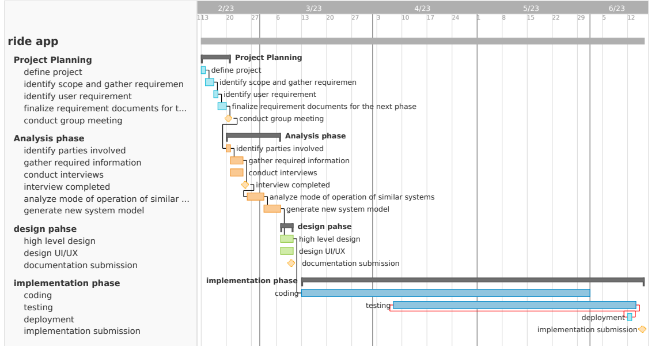

Figure 1.1: Schedule Gantt Chart

## **Project Budget**

**The budget for the project for tangible expenses is collected form team member, but most technology expenses written are used in trial basis thus their costs are not incurred expenses, rather estimated expenses.**

|  |  |  |  |
| --- | --- | --- | --- |
| *Item* | Quantity | Unit Price (in birr) | Total cost in birr |
| *Paper* |  | 2 | 50 |
|  |  |  |  |
| *Transport cost* | 5 | 20 | 100 |
| *Contingency reserve* | 150 |  | 150 |
| *Management reserve* | 100 |  | 100 |
| *Total* |  |  | 480 |

# **CHAPTER TWO**

1. **Requirement Analysis**

## 

## **Current System Description**

## **The major function of the current system**

## **The problem with the Existing System**

## **Requirement Gathering**

## **Requirement Gathering Methods**

## **Business Rules**

## **Proposed System Description**

## **Overview**

## **Functional Requirements**

## **Nonfunctional requirements**

## **Performance**

## **Scalability**

## **Availability**

## **Reliability**

## **Maintainability**

## **Security**

## **Environmental**

## **Usability**

## **Interoperability**

# **Chapter Three**

1. **System Model**

## **Scenario**

## **Use Case Model**

## **Use Case Diagram**

## **Description of Use Case Model**

## **Activity Diagram**

## **Object Model**

## **Data Dictionary**

## **Class Model**

## **Dynamic Modeling**

## **User Interface**

# **Chapter Four**

1. **System Design**

## **Introduction**

## **Current software architecture (if any)**

## **Proposed software architecture**

## **System Decomposition**

## **Hardware/ software mapping**

## **Persistent data modeling**

## **Access control and security**

## **Detailed class diagram**

## **Package Diagram**

## ***Deployment***